*Section 7 – Developmental Testing*

During a projects development it is natural for problems to occur throughout each stage. Listed below is a number of issues I ran into when writing the code for my proposed solution.

1. **Couldn’t get the output buttons to work correctly**

Below is the code showing the output buttons for bookings, Pharmacist list and Patient list:

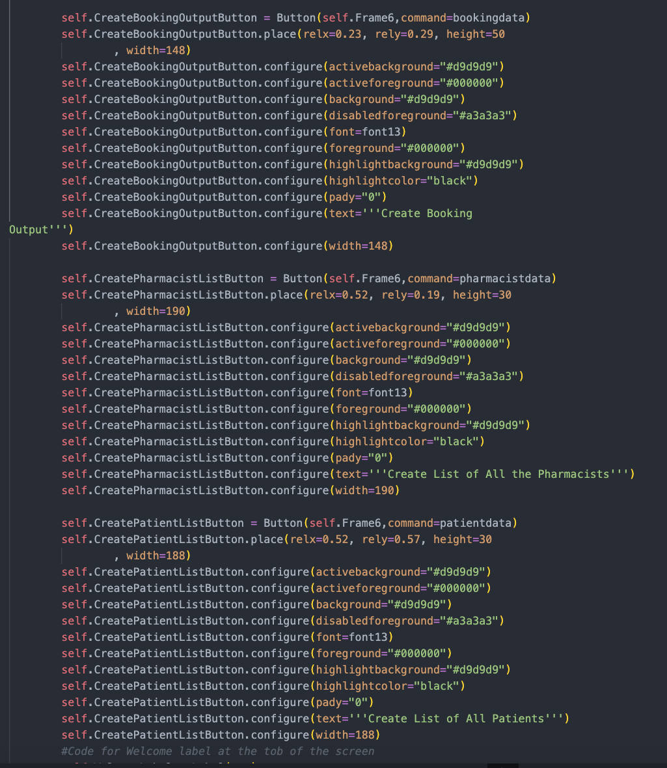

The code functions properly in that it creates the buttons I need in my solution as seen below: 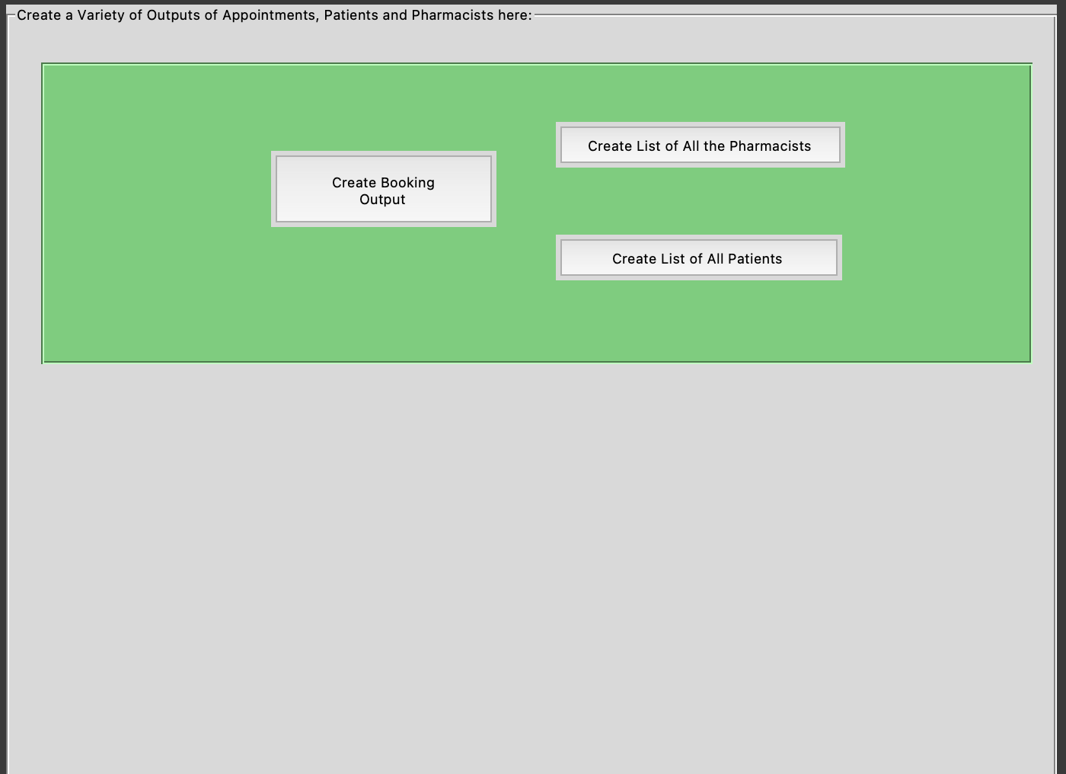

However, I could not write the correct commands for each button to properly work by using my previous method of using a “.” To call on a function from MeighPharmacyGUI_Functions.

So Imported functions for each command I needed and then wrote them to new functions inside of MeighPharmacyGUI in order for the buttons to function correctly, this is shown below: 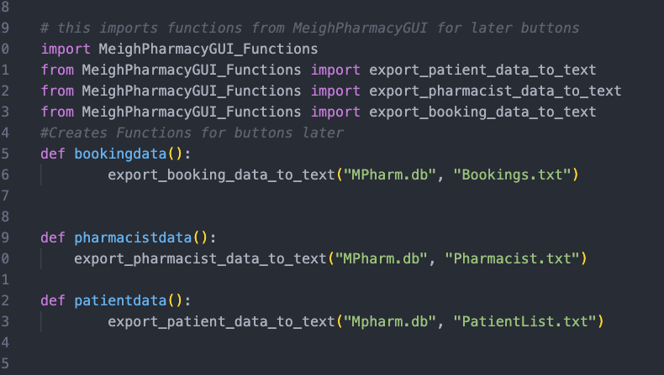

This solved my issue whilst also making my code more efficient.

1. **Entry Fields in the wrong places**

I Initially found that my entry fields were skewed and in the wrong positions due to the relx and rely values either being too high or too low. In order to fix this I used the cmd4 button on my laptop to map out the x and y values of my screen in order to match them up. Below is and example of the wrong x and y values with skewed entry tables:

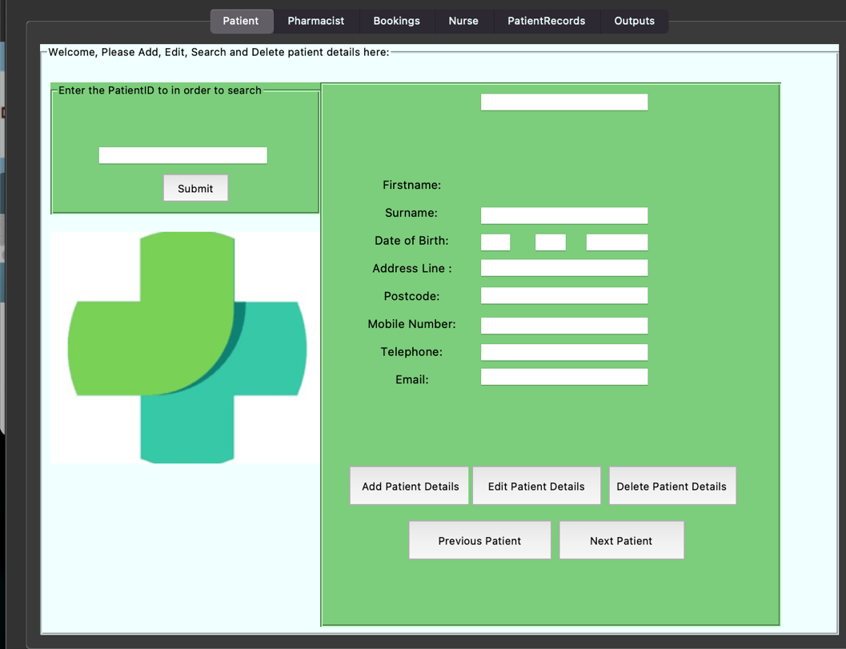

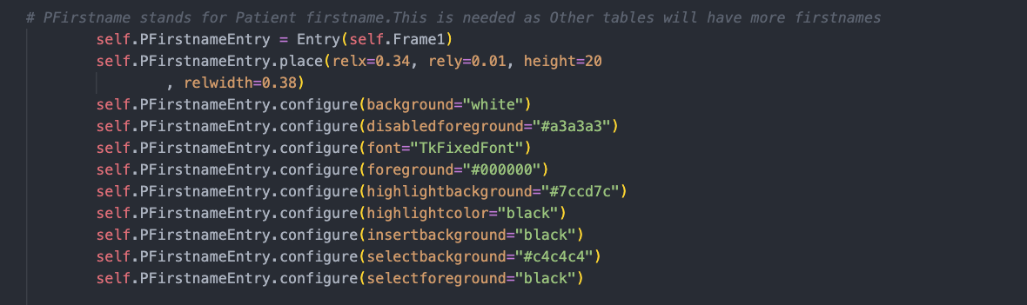

And here is the correct code with the rely and relx values corrected :

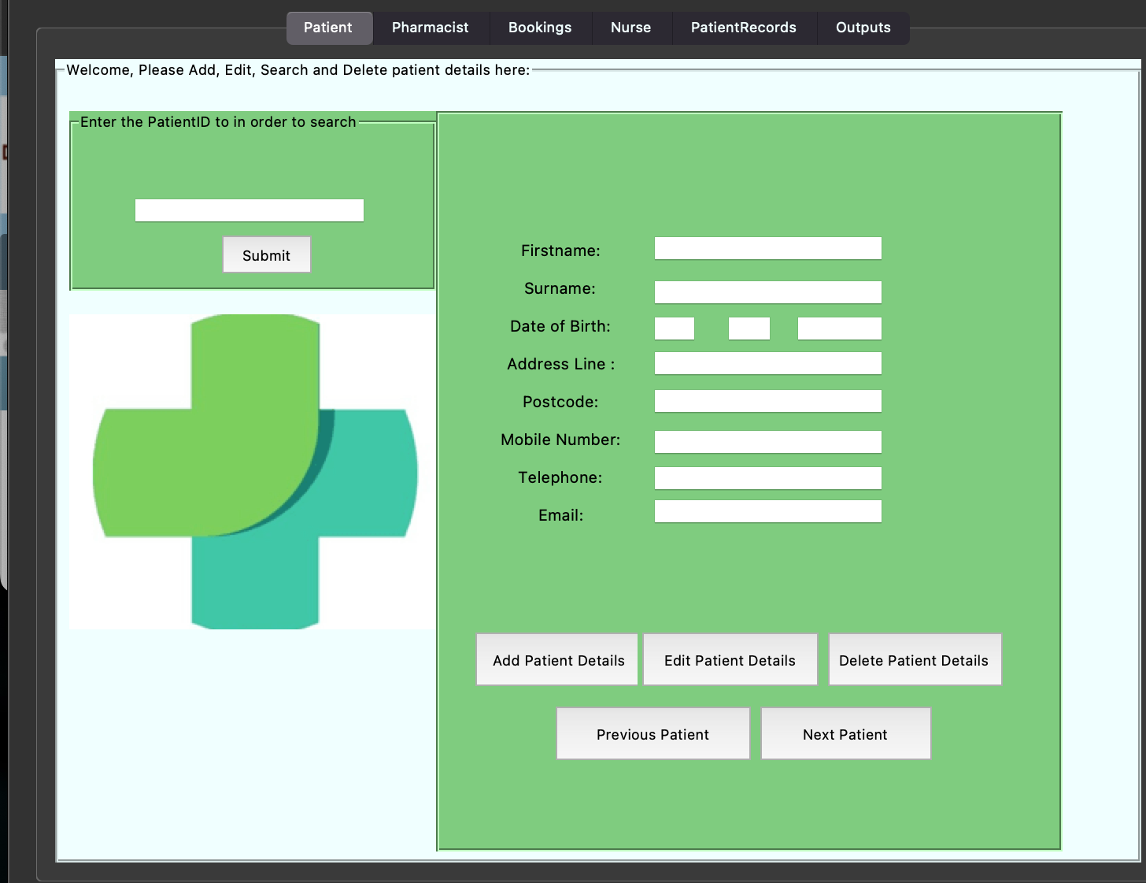

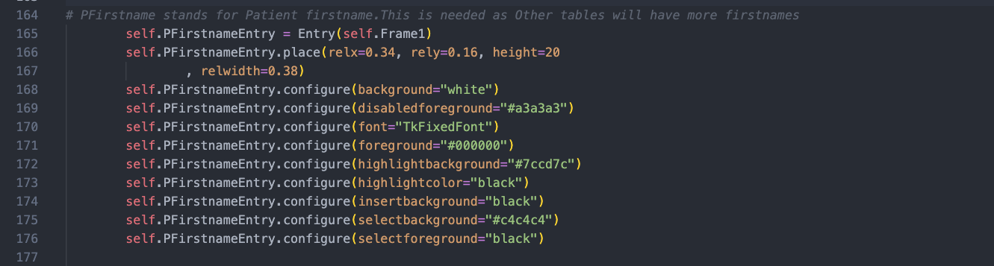

1. **Encrypting Passwords**

Security is vital in every modern system, however even more in a system like Meigh Pharmacy as it handles sensitive Data such as Patient, Nurse, or Pharmacist Data. Therefore, in my code I decided to encrypt the passwords of the users using the following code:

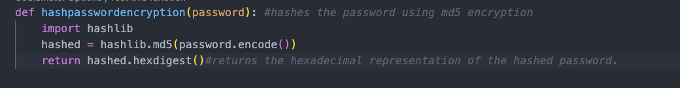

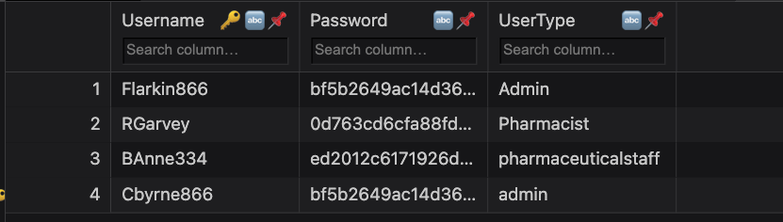

As you can see above the password is hashed so that an unexpected user can’t see the Passwords easily. One problem with this is that if a user forgets their password, they will not be able to change it, however this could be solved by developing a password recovery function.

1. **Medicine stock Table**

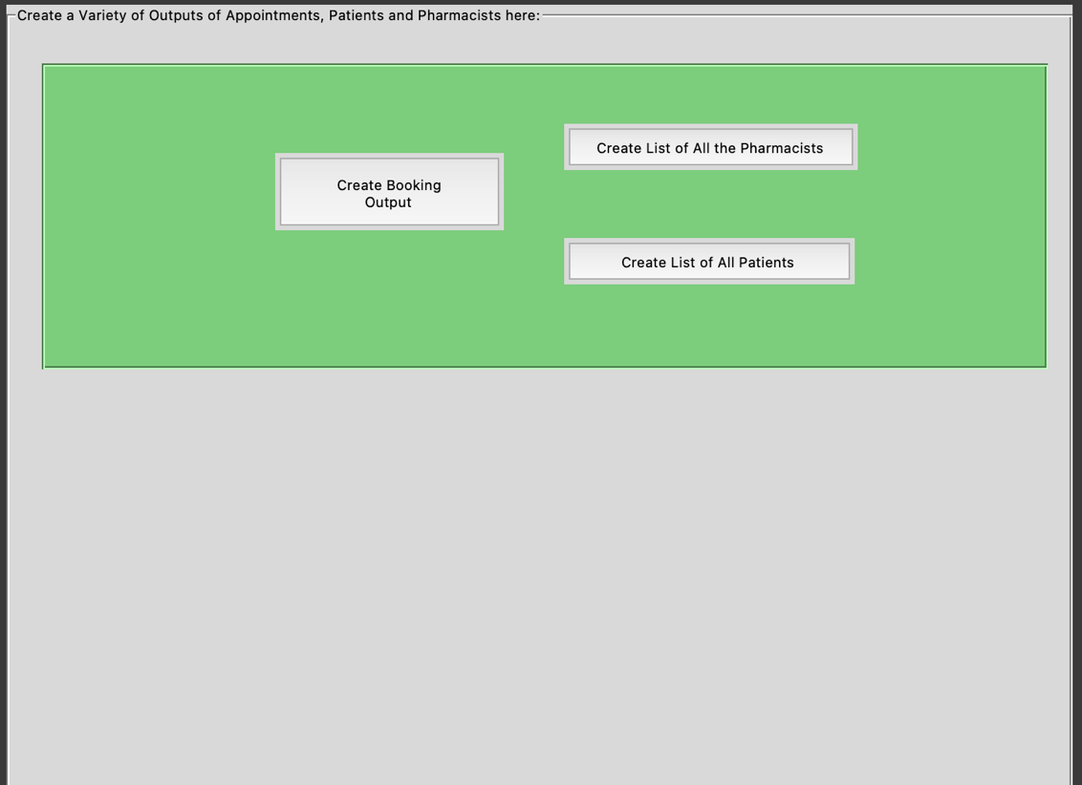Originally, I had decided in design that my system would include a Medicine stock Table. However, during development, I realized that due to the time constraints of the project I could either develop my outputs widget and not include a Medicine Stock Table or I could forget about my outputs and prioritize a fully functional Medicine Stock widget. I choose developing my output widgets as I felt it was far more important than a medicine stock table. Below is the fully developed outputs widget that takes data from the Bookings, Pharmacist, and Patient tables and exports them to text files for the user to view. This was by far the most tedious and difficult part of the solution:

1. **Improving the look of the Main menu**

Originally my main menu was quite bland and boring and in order to fix this I wrote code to add an image to the main menu whilst also changing the background colors to match the colors of Meigh Pharmacy. Below is the code to do so:

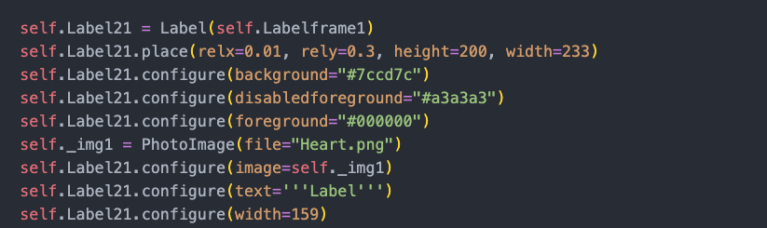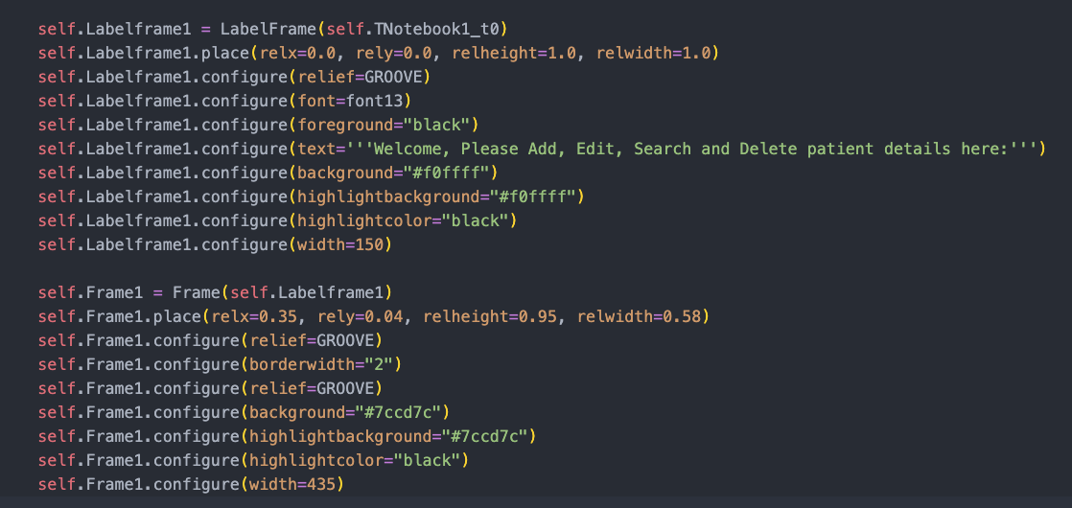

The #7ccd7c is the code responsible for the very eye-catching green in the main menu.

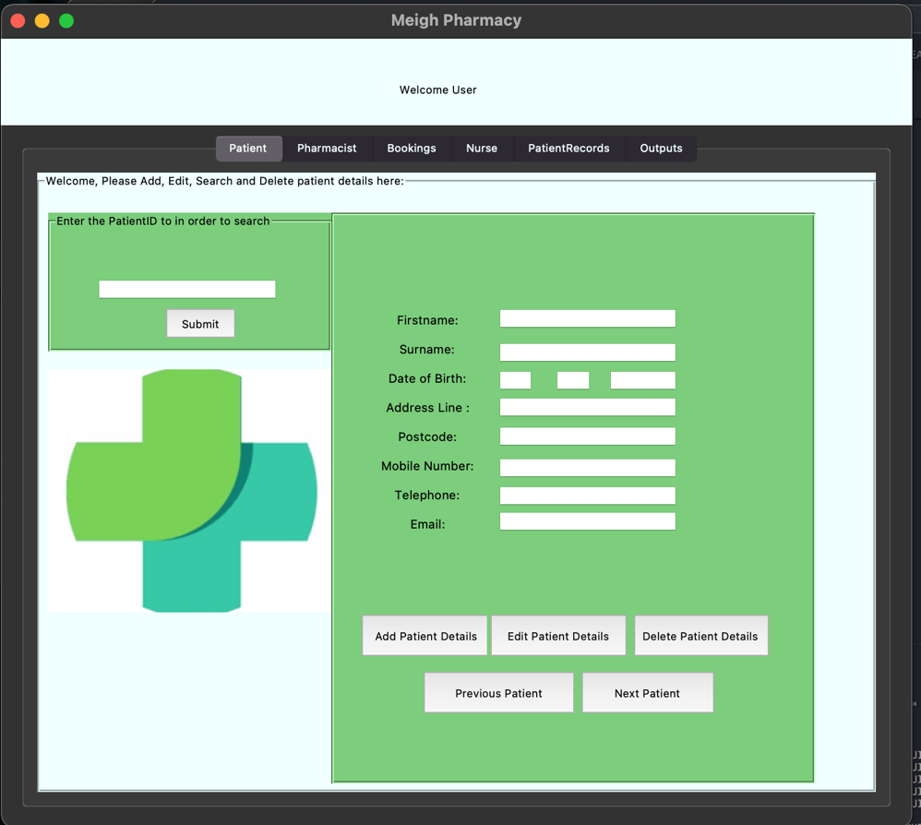Below is the final Main menu: